## CHERRY IN LINE

**Chapter 5**

**Findings, Results, and Analysis**

5.2 Electrical Audit

5.2.1 Visual inspection

The following electrical equipment comprises Cherry Inline Booster electrical installation:

|  |  |  |  |
| --- | --- | --- | --- |
| Item | Description | MODEL | BRAND |
| 1. | 150 kVA Transformer (Utility supply)) |  |  |
| 2. | SILENT DIESEL GENERATOR110kVA/88Kw, 220/440V, 60hz | HGC-80 | HEXAGEN |
| 3. | MANUAL TRANSFER SWITCH | BW400EAG | FUJI |
| 4. | LIGHTNING ARRESTER WITH COUNTER | CDR-401 | CIRPROTEC |
| 5. | SURGE PROTECTION DEVICE |  | PROTEC |
| 6. | MOULDED CASE CIRCUIT BREAKERS | BW400EAG, BW125JAG | FUJI, |
| 7. | KILOWATTHOUR METER | V-62S | CANADIAN GENERAL ELECT. |
| 8. | CURRENT TRANSFORMERS |  |  |
| 9. | MAGNETIC CONTACTORS | SC-N2S |  |
| 10. | HARMONIC FILTER, 70AMPS | VLT | DANFOSS |
| 11. | VARIABLE FREQUENCY DRIVE | VLT AQUA DRIVE | DANFOSS |
| 12. | UNINTERRUPTIBLE POWER SUPPLY |  |  |
| 13. | MINIATURE CIRCUIT BREAKERS |  | FUJI, SCHNEIDER |

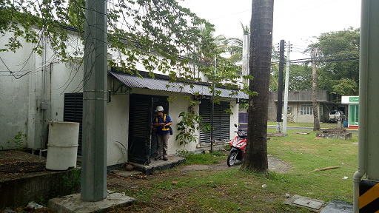 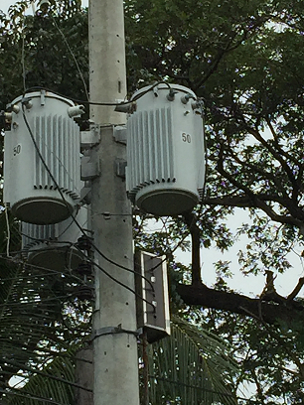 Operator’s Room Utility Pole Mounted Transformer

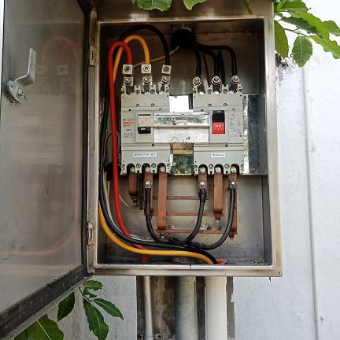 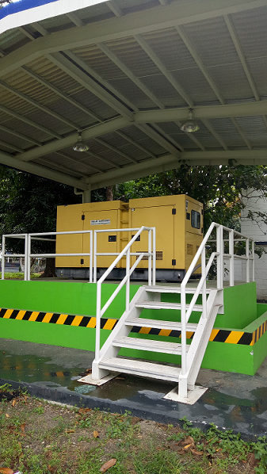 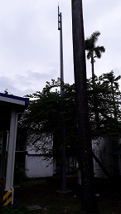

Manual Transfer Switch Genset house Lightning arrester

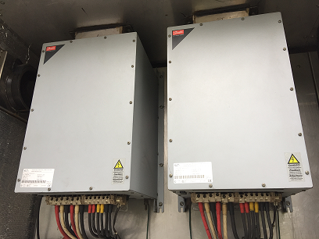 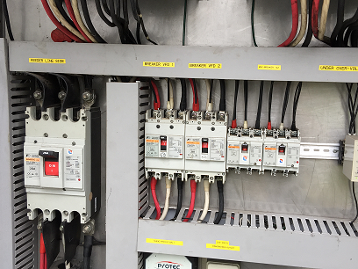 Filters ircuit Breakers

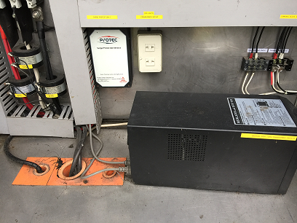 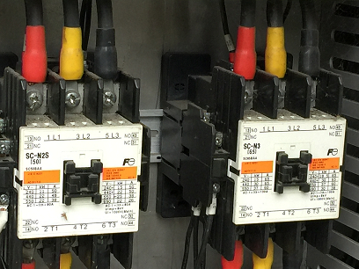

Surge Protection Device And UPS Magnetic Contactors

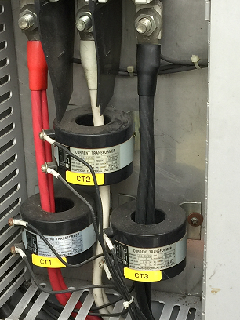 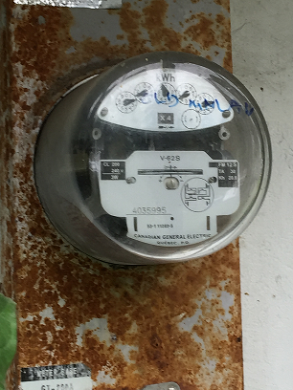

CURRENT TRANSFORMERS KILOWATTHOUR METER

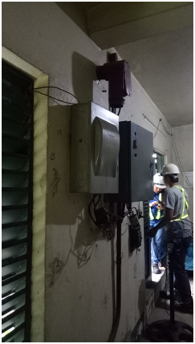 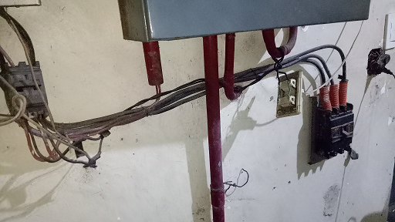

Panelboards Loose breakers